Plan Details

Assumptions:

1.) Plan details table is already created which stores the details of tour packages.

2.) Records are present in the plans table.

Functionalities:

1.) Creation of a plans table which stores all details of the plans.

2.) Displaying entire plan details using OOALV and adobe form.

3.) Adding plans using BDC.

4.) Maintaining plan details through DML operations.

Navigation:

Server:

Package:

Project: Tourism Management System

Sub-Project: Plans Details Management

Program and Adobe Form:

**Plans Details**

* Open Admin Homepage and then click on Plans List.

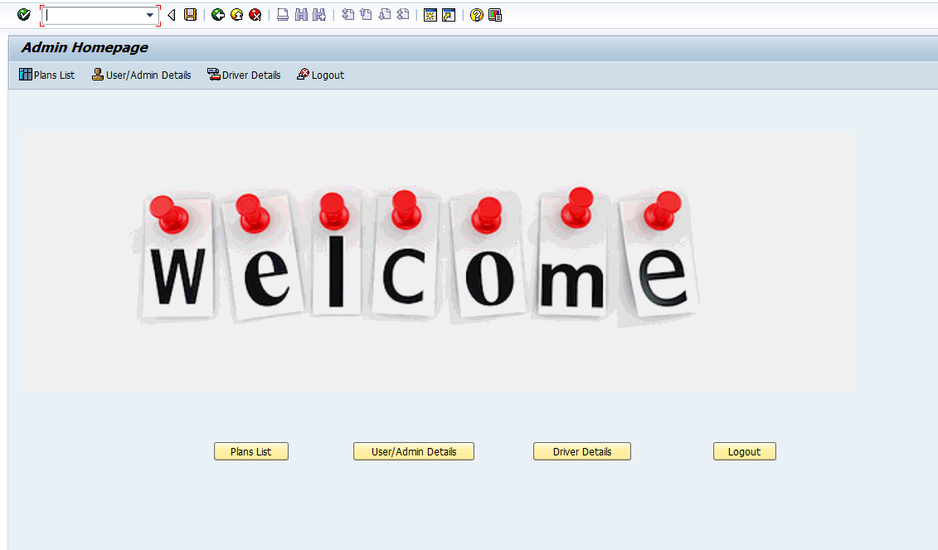

* Clicking on Plans List button will open the next window containing the list of plans and other push buttons.

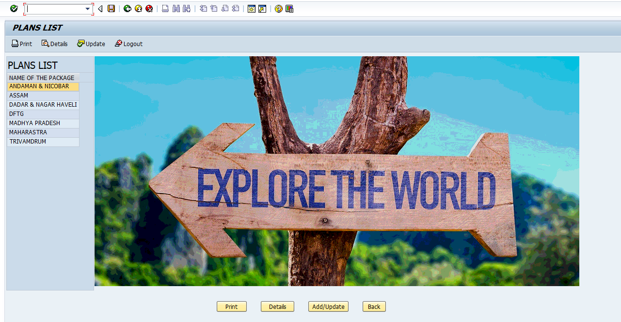

* When double-clicked on the name under plans list, another screen will open containing full details of the plan selected. Delete pushbutton will be there when going on this screen by double clicking on any plan name.

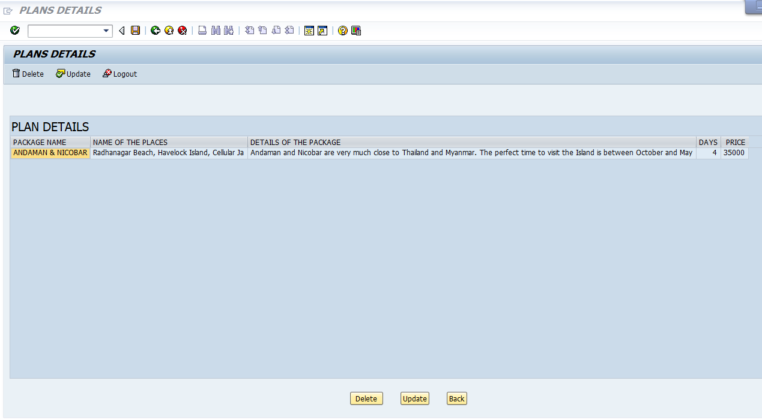

* From this screen, you can delete the entry or if you want to update something, then you can click on update push-button. When you click on update then all the details of that particular plan will be automatically filled in the text fields. When you want to change something then change that in the corresponding text field and then click on update then a message will be shown that Record has been updated successfully. If you click on add then a pop up will be displayed showing ‘Record is not added’. When you click on delete, that particular record will be deleted and a success message will be displayed. When you click on Clear Fields, text fields will be cleared. Also, there is a search help for plan names. When you select the plan name using search help, plan name will be filled. When you click on display, all the text fields will be filled showing the details of that particular plan. When there is nothing in the plan name, then clicking on display will open the screen showing all the plans and their details. **All the fields are obligatory.**

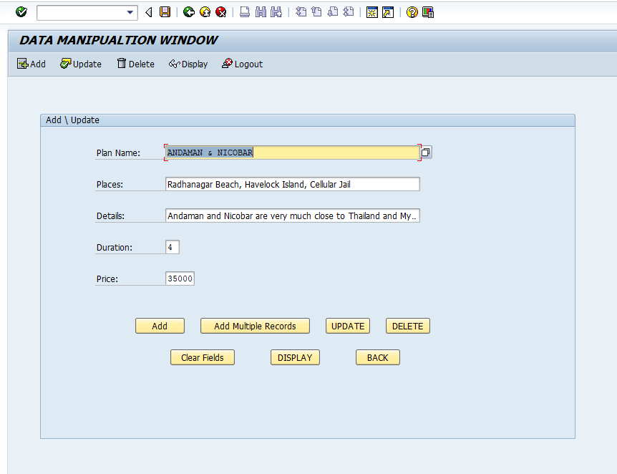

* When clicking on Add multiple records, it will open a screen giving the option to add multiple records at one time. You can add records using excel file as well as notepad file.

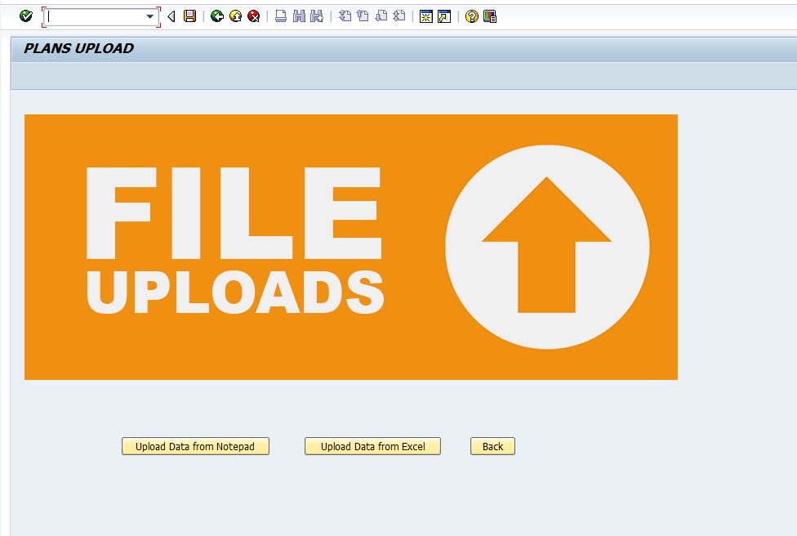



* On clicking Print pushbutton, it will print the entire plans list. It will be displayed like below image.

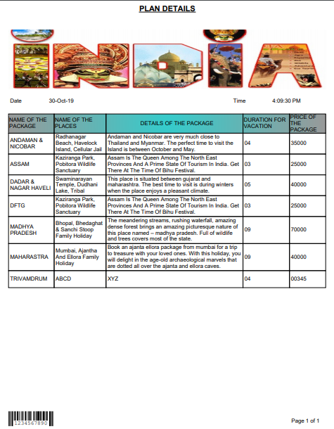

* When clicking on Details on the Plans List page, it will show the entire plans along with its details. The delete pushbutton will hide on going to that screen.

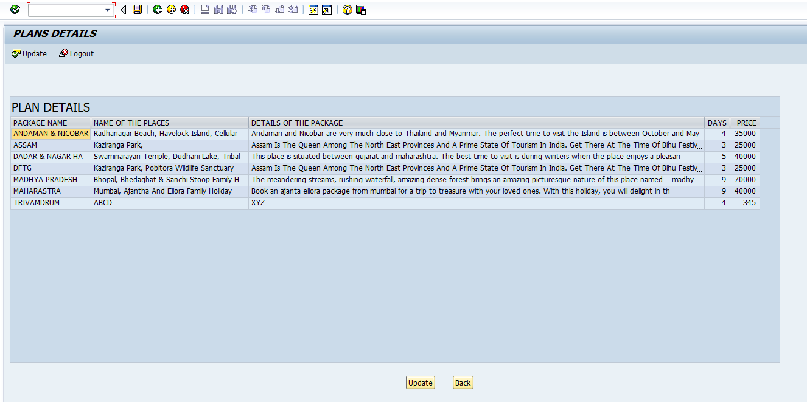

* On using Update pushbutton, it will lead you to the DML screen with empty text fields.

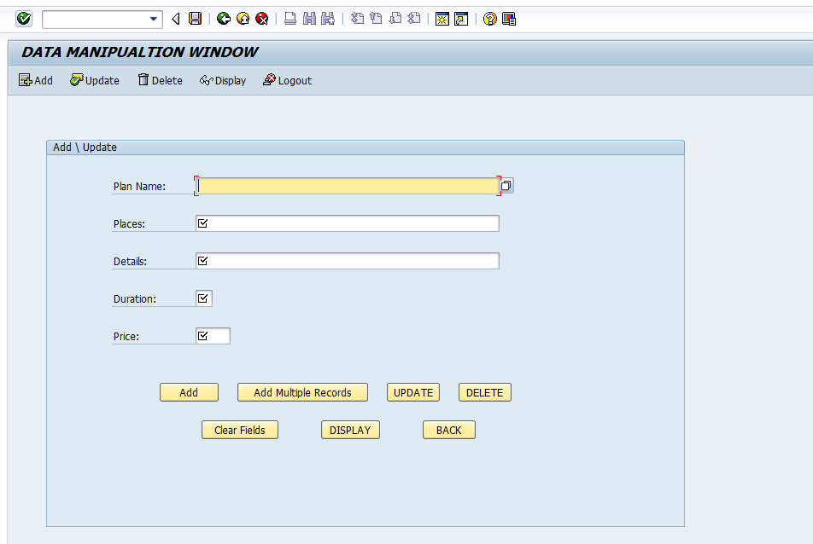

* You can use search help to see the details of the plans and to update and delete plans.

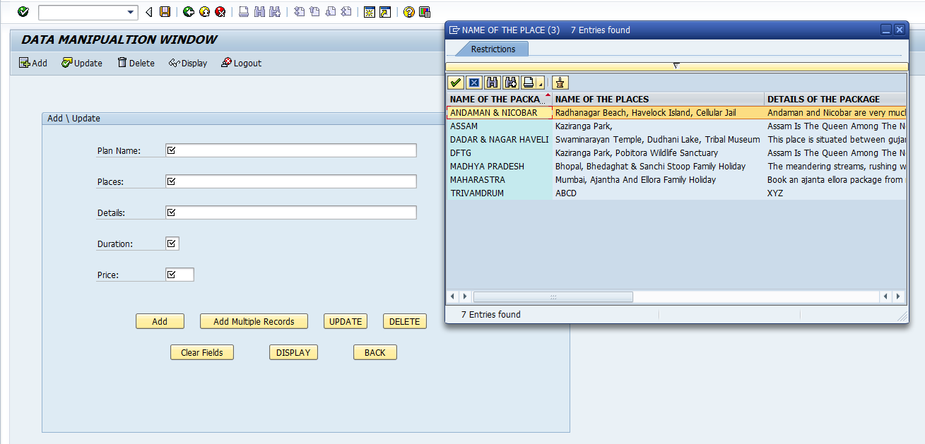

* When clicking on update on Plans List page, it will lead you to DML page with empty text fields.